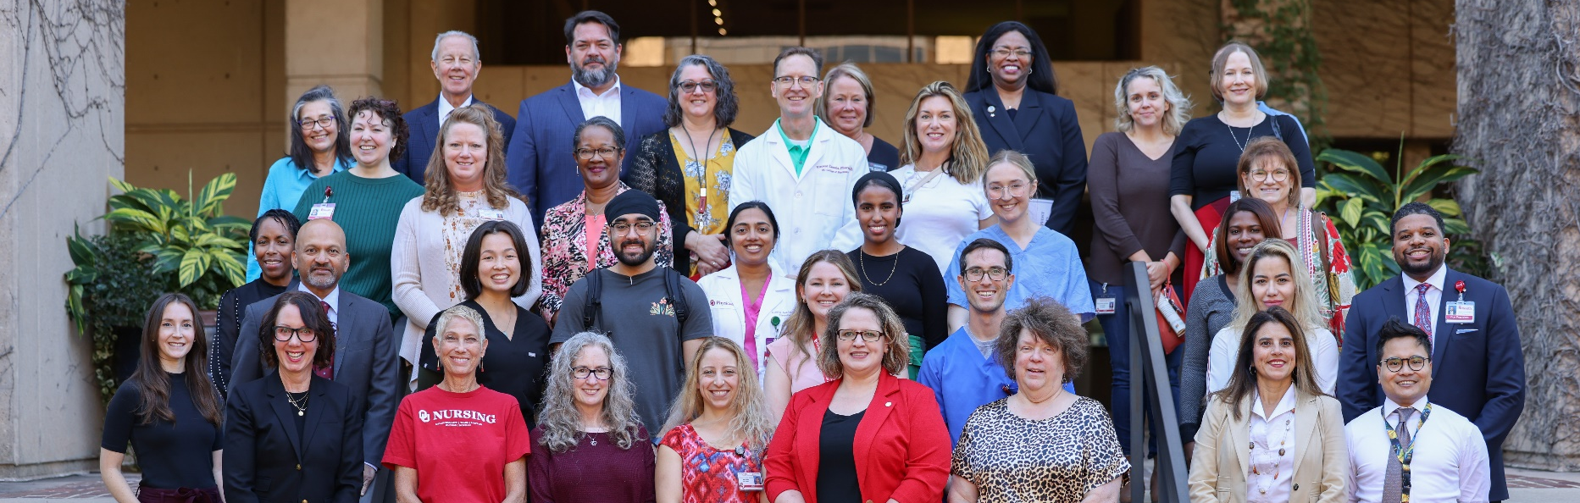
A
P
D
1

APD FACILITATOR GUIDE
Fall 2026
SUCCESSFUL TEAMING STARTS WITH YOU!
Note: Students participants will have their own handout booklet.

Table of Contents:

APD1 Agenda 2
Start with Why 3
Facilitator Expectations 4
Facilitator Tips: General 5
Getting Started 6
Facilitator Tips: Activity #1 10
Activity #1: Rapid Team Formation/Team Charter 11
Facilitator Tips: Activity #2 12
Activity #2: Elevator Speech 13
Professional Role Descriptions 14
Facilitator Tips: Activity #3 16
Activity #3: Team Communication Huddle 17
Activity #3 Debrief Questions 21

APD1 Agenda
Learners are assigned to attend by their program and must attend their assigned session for the entire two hours. Learners are required to have camera and microphone on throughout. Active participation is tracked and reported back to programs for attendance.
10:00 AM Session |  |  | 12:30 PM Session
9:45 AM | Zoom Session Opens |  | 12:15 PM | Zoom Session Opens
10:00 AM | Welcome & Introduction Video  - What is APD  - Intro IPEC Competencies  - Intro Activity #1-2 |  | 12:30 PM | Welcome & Introduction Video  - What is APD  - Intro IPEC Competencies  - Intro Activity #1-2
10:15 AM | Activity #1: Teaming  Rapid Team Formation  - Review teaming steps  - Discuss professionalism  - Decide team charter |  | 12:45 PM | Activity #1: Teaming  Rapid Team Formation  - Review teaming steps  - Discuss professionalism  - Decide team charter
10:30 AM | Activity #2: Roles & Responsibilities  Professional Elevator Speech  - 30-45 seconds each  - Everyone takes a turn  - See worksheet for example items to include |  | 1:00 PM | Activity #2: Roles & Responsibilities  Professional Elevator Speech  - 30-45 seconds each  - Everyone takes a turn  - See worksheet for example items to include
11:00 AM | Activity #3 Video |  | 1:30 PM | Activity #3 Video
11:15 AM | Activity #3: Team Communication  Irene Eagan Case Team Huddle  - Unity Clinic Team Scenario  - Decide team approach to assisting Irene where everyone contributes |  | 1:45 PM | Activity #3: Team Communication  Irene Eagan Case Team Huddle  - Unity Clinic Team Scenario  - Decide team approach to assisting Irene where everyone contributes
11:45 AM | Main Room - JTOG |  | 2:15 PM | Main Room - JTOG
11:55 AM | Adjourn |  | 2:25 PM | Adjourn
Please complete the JTOG evaluation at the link or using the QR code below:
https://redcap.link/levz2bil


Start with Why
What should  YOU  know? | Course Description  Following the Lead On, University Strategic Plan Pillar to "Empower Students for a Life of Success, Meaning, and Impact," this interprofessional first of a two-part series of interprofessional educational sessions (APD) will engage students in education related to the IPEC Core Competencies for Interprofessional Collaborative Practice including: roles and responsibilities, and communication. Students will be assigned to an interprofessional student team and will participate in a variety of active learning assignments under the guidance of a team facilitator.  Why is IPE prevalent at all academic health centers nationwide?  National accreditation bodies have adopted interprofessional education as a method of teaching collaboration among health sciences learners with the intention of creating a team-ready workforce. Team-readiness is sought to improve employee communication, reduce unnecessary safety errors – a leading cause of harm to patients – and subsequently improve health outcomes.
 | A special thank you to our facilitators!  Whether this is your first time, or your tenth time, your impact is significant. Your students today will remember you for years to come.  Thank you for your time, your expertise, and your willingness to guide learners from across campus. We couldn’t do IPE without you!


Facilitator Expectations

Staff Contact: Margaret Robinson
Phone: 405-822-3716
Please Text

Before the Session
- Log-in early to zoom using link provided by
Margaret Robinson:
  - Test Audio
  - Test Speaker
  - Test Microphone
- Have Facilitator Instructions either open
on computer or printed for access.

During the Session
FACILITATOR:
THE GUIDE
ON THE SIDE
- You will be placed in a breakout room with students from multiple professions.
- Facilitate team activities.
  - Instructions included on following pages.
- Goal: Ensure all students are participating and answer any questions.
- Alert the zoom host of any issues or questions.
Tip: Facilitators get to guide their teams in APD activities. You don’t have to lecture today.

After the Session
- Facilitators complete evaluation at https://bbmc.ouhsc.edu/redcap/surveys/?s=KK7DD99DYXWXPXJ8
- Contact Margaret-Robinson@ou.edu with any feedback or highlights.

Facilitator Tips: General
 | Stay engaged and model strong participation |  | Enforce time limits
 | Clarify objectives of activity  (Objective box on each direction sheet) |  | Refocus conversations not pertinent to task
 | Remain neutral |  | Deal constructively – and promptly – to conflict
 | Let students know they will be called on in advance |  | Silence is okay. Student responses may be slower on zoom.
 | Round-robin responses to allow everyone time to speak |  | Mute mice or limit background noise when not speaking.

 Tips
Student has poor audio? | Ask them to participate using the chat. Read their responses to the team.
Student has poor video? | Verify they are present. Allow them to participate with their camera off.
Student is not participating? | Alert the student that you will be coming to them next to respond to a question. Advance notice build psychological safetys and encourages participation.
You’ve run out of questions? | Consider additional case study examples or ethics discussions that could facilitate general discussion with early career learners. Please keep your team engaged!

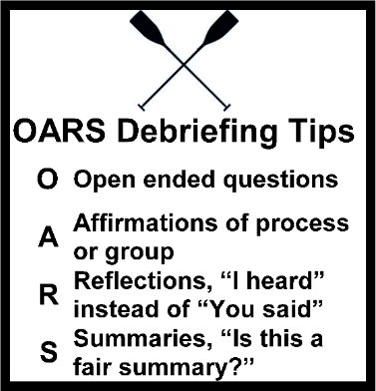
“OARS” Debriefing Process
Facilitator Tip: This technique can be used to guide your discussions with students after an activity.
O | Open ended questions (examples included with activities)
A | Affirmations of process or group
R | Reflections, “I heard” instead of “You said”
S | Summaries, “Is this a fair summary?”

Getting Started

A video will be played in the main zoom room reviewing the information on the next few pages. Facilitators do not need to do anything at this time.

Student Information

Definitions


Interprofessional Education
“Interprofessional education occurs when students from two or more professions learn about, from, and with each other to enable effective collaboration and improve health outcomes.”
World Health Organization. (‎2010)‎. Framework for action on interprofessional education and collaborative practice. World Health Organization. https://apps.who.int/iris/handle/10665/70185

IPEC Core Competencies
Learning Objective:
- Define the IPEC Core Competencies

Roles & Responsibilities

“Using the knowledge of one’s own role and team members’ expertise to address individual and population health outcomes.”

Communication
“Communicate in a responsive, responsible, respectful, and compassionate manner with team members.”

Values & Ethics
“Working with team members to maintain a climate of shared values, ethical conduct, and mutual respect.”

Teams & Teamwork
“Applying values and principles of the science of teamwork to adapt one’s own role in a variety of team settings.”

Interprofessional Education Collaborative. (2023). IPEC Core Competencies for Interprofessional Collaborative Practice: Version 3. Washington, DC: Interprofessional Education Collaborative. https://www.ipecollaborative.org/ipec-core-competencies

Student Information Continued

Team Formation
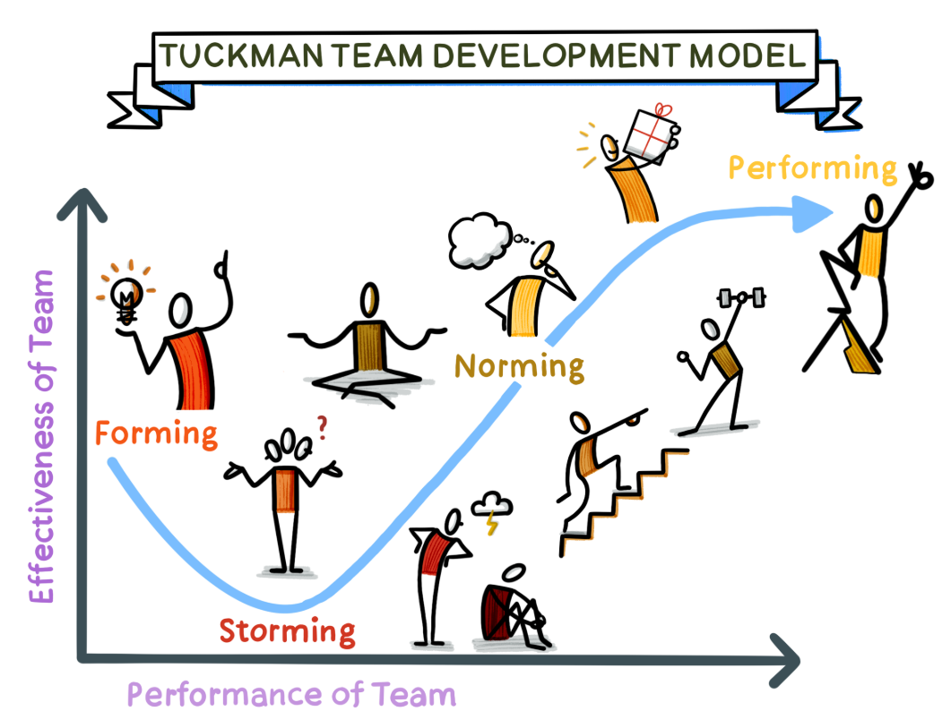
https://www.thevisualfacilitator.co.uk/blog/tuckmans-model-of-team-development

OFTEN MISSED | - Forming: The team comes together and begins to understand its goals and objectives. There may be uncertainty and some initial discomfort as team members get to know each other.
OFTEN MISSED | - Storming: Conflict arises as team members begin to establish their roles and responsibilities. This stage can be uncomfortable, but it’s important for team members to voice their opinions and work through any disagreements.
OFTEN MISSED | - Norming: The team begins to establish a sense of cohesion and unity. Team members understand each other’s strengths and weaknesses, and they work together to achieve their goals.
COMMON TEAMING | - Performing: The team is fully functional and able to work efficiently and effectively. Team members trust each other and are committed to achieving their objectives.
COMMON TEAMING | - Adjourning: The team is disbanded, either because the project has been completed or because the team members have moved on to other projects.

Rapid Team Formation
Requires we stop and quickly:
- Make sure we know who is on the team
- Confirm everyone knows the goal
- Confirm everyone knows their tasks
- Use team communication skills

Student Information Continued

Communication Skills

Closed Loop Communication
“Closed-loop communication uses verbal feedback to ensure that messages are correctly understood by recipients using methods including call-outs, check-backs, and teach-back.”
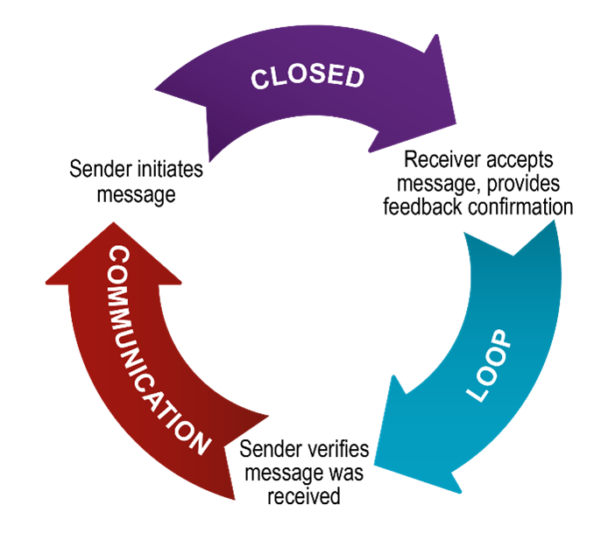
https://www.ahrq.gov/teamstepps-program/curriculum/communication/tools/loop.html

Check Back Method
“A check-back, which is sometimes called a repeat-back, is a closed-loop communication strategy used to verify and validate exchanged information. When a team member calls out information, they typically anticipate a check-back in response to verify that the information was received.”

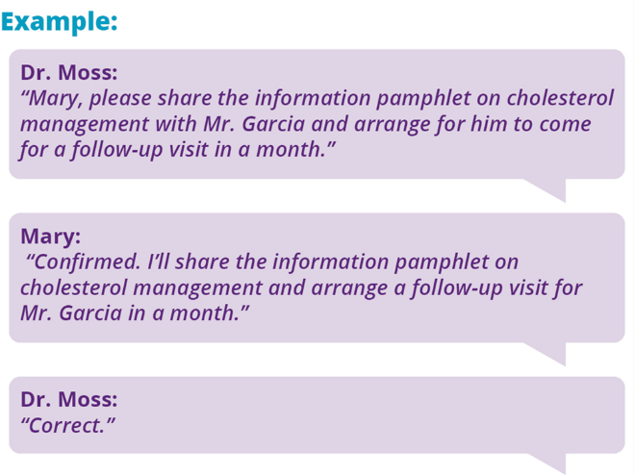
https://www.ahrq.gov/teamstepps-program/curriculum/communication/tools/checkback.html

Student Information Continued

Effective Communication
- Complete. Communicate all relevant information.
- Clear. Convey information in plain language.
- Brief. Communicate information in a concise manner.
- Timely. Offer and request information in an appropriate timeframe.
- Respectful. Use communication to foster psychological safety and affirm other team members, not just to give instructions or share information.

This includes being professional, paying attention to others, reducing distractions when others are speaking, making eye contact by looking into the camera, minding your body language such as nodding your head to show engagement, and speaking up and participating when it is your turn.

Zoom Activity Professionalism
APD2 is assessed by participation. Facilitators will be monitoring and reporting participation for attendance. Participation in a professional zoom environment is similar to classroom expectations.
Students are expected to be present, to participate, and to be respectful of their colleagues.



 | You will be automatically assigned to a breakout room.  - Be ready to start with activity #1.  - Instructions follow on the next page.  - You may screenshare to make it easy.  - Stay in the breakout room until the JTOG evaluation at the end.

Facilitator Tips: Activity #1

See next page for the Activity #1 Worksheet to share with students.
Start  Here | - Set timer for 15 minutes.  - Introduce yourself and your background.  - Students can enter their names in the chat for quick introductions – or ask them to change their name on their profile.  - NOTE: Activity #2 will have more in-depth introductions.
 | - Share screen with Activity #1 Worksheet (next page) – or ask a student participant to be the notetaker.
Set Expectations | - A team charter is similar to how any group-work assignment starts  - This is an easy assignment while everyone gets comfortable and their zoom audio gets connected  - No right or wrong answers  - Everyone should contribute something  - These will be the rules of the road for the rest of the session
GOAL | - Rapid team formation steps: forming, storming, and norming. Performing will be in Activities #2-3.  - Focus on getting comfortable with the situation, setting team goals.
Deliverable | - A list of Team Goals and Communication Agreements
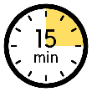 | - Keep engaged for 15 minutes. Suggestions if you finish early:  - Use round-robin technique to get feedback from all participants  - When ready, move on to the next Activity
End | - At time, a note will appear at the top of the screen.  - Move on to Activity #2

Activity #1: Rapid Team Formation/Team Charter

Instructions:
Learning Objective:
- Apply steps of rapid team formation to create a team charter
- Make sure everyone has their camera and microphone on.
- Facilitator will share screen and take notes (or another student can).
- As a team, decide your goals and communication agreements for today. A few examples are provided.

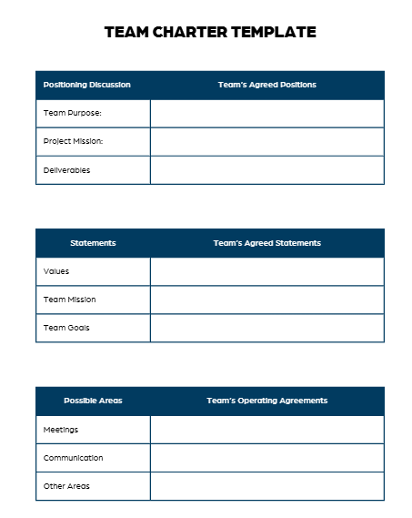
Team Goal Examples:
- Complete all tasks on time
- Complete all tasks with quality
- Complete all tasks above and beyond
- Apply critical knowledge and the best of our training to the task
- All members have critical knowledge

Team Communication Examples:
- All members take turns speaking
- No one speaks over anyone else
- Use respectful language
- We’ll report anyone not participating back to their program

Team Goals

Team Operating Agreements: Communication

Facilitator Tips: Activity #2

See next page for the Activity #2 Worksheet to share with students.
Start Here | - Set timer for 30 minutes.
 | - Share screen with Activity #2 Worksheet (next page) – or ask a student participant to be the notetaker.
Set Expectations | - All students should participate  - No one will be graded. There are no wrong answers.
GOAL | - Rapid team formation steps: Finishing Forming, Storming, and Norming, beginning Performing
Deliverable | - Each student creates an Elevator Speech about their Roles & Responsibilities
Guide on the Side | - You do not have to correct a student’s speech, but you can nudge them to additional resources if needed.  - Remind students they can use google, AI, or the Professional Role Descriptions handout on the following pages.
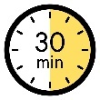 | - Keep engaged for 30 minutes. Suggestions if you finish early:  - Use the debrief questions on the next page
End | - At time, a note will appear at the top of the screen.  - Stay in your breakout room  - A Video for Activity #3 will automatically play at 11:00 am/ 1:30pm

Activity #2: Elevator Speech

Instructions
Learning Objective:
- Articulate professional role and responsibilities to teammates in a 30-45 second elevator speech
- Take a few minutes to type
3-4 sentences as an elevator speech.
- The facilitator will call time.
- Everyone will turn on their microphone and video.
- Each person will upload their elevator speech to the chat.
- Go around the zoom room and each person unmute and say their elevator speech.
- If time permits, review the debrief questions below as a team.

CRAFTING AN ELEVATOR SPEECH
Professionally articulate your role/responsibilities to colleagues on campus.
Identify Yourself | Know Your Audience | Craft Your Message | Answer Their Questions First
Items to include: Name, program, year, campus, if you would like to connect. Consider tone and body language. Don’t use jargon or acronyms. | Tailor your speech to the interests and needs of your audience to ensure relevance and engagement. | Determine what you want to achieve, be concise, and practice as needed. | Consider their possible questions:  - What is your profession (role) and what do you do (responsibilities)?  - Where are you from? Where do you want to go?  - Why did you choose your profession? What are you passionate about?  - Is your program undergrad, graduate, or professional? How long will it take? When will you graduate?  - What are your goals, what do you want to do when you graduate?  - How can you/your position help them?

My Elevator Speech (upload to the chat)

Debrief  Corner | - Would you change yours now after hearing someone else’s?  - How can you ask someone on campus for their introduction?  - Why is the elevator speech important to improve teamwork?  - How can you do this on the spot during school/work hours?

Professional Role Descriptions
Below is a collection of simple role descriptors. Add to it as you learn more today.
Audiology | Audiologists are healthcare professionals who provide patient-centered care in the prevention, identification, diagnosis, and evidence-based treatment of hearing, balance, and other auditory disorders for people of all ages. Hearing and balance disorders are complex with medical, psychological, physical, social, educational, and employment implications. https://www.asha.org/public/who-are-audiologists/
Research Scientist | Research scientists ask important questions, carry out experiments to test their questions, and ultimately provide new knowledge to better understand various aspects of biological processes involved in health and disease.  - Basic Researcher: Basic medical researchers typically focus on the basic building blocks of life, such as DNA, cells, proteins or chemicals, and do not routinely study human subjects or animals directly.  - Clinical Researcher: Clinical researchers focus on studies that explore whether new treatments, medications, devices or diagnostic techniques are safe and effective in human subjects.  - Translational Researcher: Translational researchers bridge the gap between basic science and clinical research to refine and advance the application of a basic science discoveries toward safely testing in human subjects with clinical trials; they are often part of inter-disciplinary teams solving complex biomedical problems.  https://blog.dana-farber.org/insight/2017/12/basic-clinical-translational-research-whats-difference/
Dentistry | Dentistry is the evaluation, diagnosis, prevention and/or treatment (nonsurgical, surgical or related procedures) of diseases, disorders and/or conditions of the oral cavity, maxillofacial area and/or the adjacent and associated structures and their impact on the human body; provided by a dentist, within the scope of his/her education, training and experience, in accordance with the ethics of the profession and applicable law. https://www.ada.org/
Dietitian | Nutrition and Dietetics reflects the integration of nutrition—which encompasses the science of food, nutrients and other substances contributing to nutrition status and health, with dietetics—which is the application of food, nutrition and associated sciences, to optimize health and the delivery of care and services for individuals and groups. https://www.eatrightpro.org/practice/quality-management/scope-of-practice
Nuclear Medicine | Nuclear medicine is a medical technology that utilizes sealed and unsealed radioactive materials for diagnostic, treatment, and research purposes. Nuclear medicine instrumentation may be combined with, computed tomography (CT), magnetic resonance imaging (MRI), or other modalities to produce three-dimensional images with or without adjunctive and other imaging medications to enhance the evaluation of physiological processes at a molecular level. https://snmmi.org/
Nursing | Who: Registered Nurses (RN) and Advanced Practice Registered Nurses (APRN) comprise the “who” constituency and have been educated, titled, and maintain active licensure to practice nursing. What: Nursing is the protection, promotion, and optimization of health and abilities; prevention of illness and injury; facilitation of healing; alleviation of suffering through the diagnosis and treatment of human response; and advocacy in the care of individuals, families, groups, communities, and populations.  https://www.nursingworld.org/practice-policy/scope-of-practice/
Occupational Therapist | Occupational therapy services are provided for habilitation, rehabilitation, and the promotion of health and wellness to those who have or are at risk for developing an illness, injury, disease, disorder, condition, impairment, disability, activity limitation, or participation restriction. Occupational therapy addresses the physical, cognitive, psychosocial, sensory-perceptual, and other aspects of performance in a variety of contexts and environments to support engagement in occupations that affect physical and mental health, wellbeing, and quality of life. https://ajot.aota.org/article.aspx?articleid=2477354
Pharmacist | While pharmacists remain committed to assisting patients with access and information related to their prescription medications, pharmacists today are providing a broad spectrum of services, within their scope of practice, including conducting health and wellness testing, managing chronic diseases and performing medication management, administering immunizations, and working in and partnering with hospitals and health systems to advance health and wellness and helping to reduce hospital readmissions. https://www.pharmacist.com/
Physical Therapist | Physical therapy is a dynamic profession with an established theoretical and scientific base and widespread clinical applications in the restoration, maintenance, and promotion of optimal physical function. Physical therapists are health care professionals who help individuals maintain, restore, and improve movement, activity, and functioning, thereby enabling optimal performance and enhancing health, well-being, and quality of life. Their services prevent, minimize, or eliminate impairments of body functions and structures, activity limitations, and participation restrictions. http://www.apta.org/ScopeOfPractice/
Physician | Physicians and surgeons diagnose and treat injuries or illnesses. Physicians examine patients; take medical histories; prescribe medications; and order, perform, and interpret diagnostic tests. They counsel patients on diet, hygiene, and preventive healthcare. Physicians can hold a MD or DO license and are specialized in an area of medicine . https://www.ama-assn.org/
Physician Associate | A broad, generalist medical education prepares PAs to take medical histories, perform physical examinations, order and interpret laboratory tests, diagnose illness, develop and manage treatment plans for their patients, prescribe medications, and assist in surgery. https://www.aapa.org/wp-content/uploads/2017/01/Issue-brief_Scope-of-Practice_0117-1.pdf
Public Health | Public health professionals focus on preventing disease and injury by promoting healthy lifestyles. They implement educational programs, develop policies, administer services, conduct research, and regulate health systems to achieve these goals. The public health field confronts global health issues, such as improving access to health care, controlling infectious disease, and reducing environmental hazards, violence, substance abuse, and injury. https://www.aspph.org/discover/
Public Health | - Community & Population Health  - Epidemiology & Biostatistics  - Environmental & Occupational Health | - Health Promotion  - Healthcare Administration
Radiation Therapy | The practice of radiation therapy is performed by health care professionals responsible for the administration of ionizing radiation for the purpose of treating diseases, primarily cancer. Radiation therapy integrates scientific knowledge, technical competence and patient interaction skills to provide safe and accurate treatment with compassion. A radiation therapist recognizes patient conditions essential for the successful completion of simulation and treatment. https://www.asrt.org/docs/default-source/practice-standards-published/ps_rad.pdf?sfvrsn=2
Radiography | The practice of radiography is performed by health care professionals responsible for the administration of ionizing radiation for diagnostic, therapeutic or research purposes. A radiographer performs radiographic procedures at the request of and for interpretation by a licensed practitioner. https://www.asrt.org/main/standards-and-regulations/professional-practice/practice-standards
Social Worker | Clinical social work has a primary focus on the mental, emotional, and behavioral well-being of individuals, couples, families, and groups. It centers on a holistic approach to psychotherapy and the client’s relationship to his or her environment. Clinical social work views the client’s relationship with his or her environment as essential to treatment planning. https://www.socialworkers.org/Practice/Practice-Standards-Guidelines
Sonography | The diagnostic medical sonographer is an individual who provides patient care services using ultrasound and related diagnostic procedures. The diagnostic medical sonographer must be educationally prepared and clinically competent as a prerequisite to professional practice. https://www.sdms.org/about/who-we-are/scope-of-practice
Speech Language Pathologist | The overall objective of speech-language pathology services is to optimize individuals' abilities to communicate and to swallow, thereby improving quality of life. As the population of the United States continues to become increasingly diverse, SLPs are committed to the provision of culturally and linguistically appropriate services and to the consideration of diversity in scientific investigations of human communication and swallowing. https://www.asha.org/policy/SP2016-00343/

Facilitator Tips: Activity #3

See next page for the Activity #3 Worksheet to share with students.
 | - The video for Activity #3 will automatically play in your breakout room at 11:00 am / 1:30 pm
Start Here | - After the video, set timer for 30 minutes.
 | - Share screen with Activity #3 Worksheet (next page) – or ask a student participant to be the notetaker.
Set Expectations | - All students should participate  - No one will be graded. There are no wrong answers.  - Focus on team communication, not the patient or the case  - Keep discussion generic, most learners are just getting started in their programs.
GOAL | - Rapid team formation steps: Performing
Deliverable | - A successful team huddle discussion
Guide on the Side | - Lead group discussion, allow everyone to contribute.  - Start with question one, come to consensus, then move on to the next section.  - Consider providing context or additional details about the Social Determinants of Health, as needed
- Keep engaged for 30 minutes. Suggestions if you finish early:
  - Use round-robin technique to get feedback from all participants
  - Ask pointed questions to involve all professions, such as what is the role of research
  - When ready, move on to the debrief questions
End | - At time, a note will appear at the top of the screen.  - Everyone will return to the main session for JTOG evaluation and wrap-up

Activity #3: Team Communication Huddle

Instructions
Learning Objective:
- Demonstrate team communication through a team huddle on a patient case.
- The case study video will automatically play in the breakout room. You may take notes.
- As a team, practice a team huddle to plan how to care for the patient at the clinic.
- Use the questions below - or come up with new questions.
- If time permits, review the debrief questions on the next page as a team.
- When time is called, all teams will return to the main session for evaluation.

NOTE: The goal is to practice team communication – not to know the patient health information or diagnosis.

All team members from any health science program can contribute to the discussion ranging from research, theory, prerequisite knowledge, or previous experience.

Team Huddle Worksheet
Possible Questions | Responses
- What do we know about the situation and the patient?

- Who is on our team and how can they help?

- What do we still need to know?

- What social determinants of health (SDOH) are involved? How can we consider SDOH?

- What are our priorities for the team, patient, clinic today?

- How will each team member contribute today?

- Other questions?

Irene Eagan’s Script

Irene: I have an appointment today with the Unity Clinic. They said I could be seen here for my dental and my health since I don't have insurance. I did apply for Medicaid, but they said I didn't qualify. Is there a way I can answer the questions because my glasses are not up to date. I haven't been to the eye doctor, so I cannot read the forms.

Team Member: I can help you with all those forms. What is your name?

Irene: Irene.

Team Member: Irene, what brings you in today?

Irene: I have a horrible tooth ache and I think it might be infected. There is a dentist by my house, and my friend suggested I try to get Medicaid. But, they said they only do extractions, and since I didn't qualify anyway. I went to my friend’s dentist that she suggested and they will not treat it because I'm diabetic. My levels were 300. I called around and I found you guys, the Unity Clinic.

Team Member: Okay, well, I think that that's something we can help you with. I'm very sorry to hear about all of that. Are you on any medications right now for your diabetes?

Irene: Well, the doctor prescribed some medication a while back, but, it upset my stomach a lot. I remember talking to the pharmacist and he suggested to ask for another prescription, another different pill, but I didn't remember the name. And I know I should be eating better, less carb and kind of on a diet, but, we eat whatever we have at home. And with my teeth, it is even difficult to chew or swallow. It makes it more difficult for my food, to pass my food, unless it's very soft. And, I’m eating just certain things right now because of my tooth as well. I know I have to exercise, but I also have a problem with my feet. They hurt so much. And, when I walk. I can’t even walk a few steps without resting or getting a lot of pain. So, they also suggest, the other doctor suggested, I do an ultrasound on my feet. Is there something also that you can do here or help me with that issue as well?

Team Member: Potentially. I really quickly want to go back and ask about your eating. Is it ever hard for you to swallow?

Irene: It is. It is very hard for me to swallow as well.

Team Member: And, the ultrasound, did you ever have the ultrasound done?

Irene: They did the referral, but no, I was just waiting for them. It never happened.

Team Member: Well, we can definitely look into all of that for you today. Did anyone take your vitals yet?

Irene: The nurse did. She said my high blood pressure was very high. And my blood sugar. I didn't want to go to the scale, but I know it's important. But yes, she did. She came in and took my vitals.

Team Member: Well, I do have a few more questions to ask. These are questions we ask everyone, but they can seem a little bit weird. The next piece of paper they gave you was called the Social Determinants of Health Screener. The first question on it is: In the last month, have you had concerns about your housing?

Irene: Yes, it's been very hard to pay the bills and the rent. My husband had lung cancer. He even went through a clinical trial trying to find out a cause. They even went to study his work site. My husband worked in a factory for many years. They said perhaps his lung cancer happened because of the environment where he was. All through this time. I wonder is that why he got sick with lung cancer? Even though he fought very hard, he did pass away. It's been very hard for me also financially. Paying my rent and my utilities has been very difficult. I wonder, is there something that you can help me with also with some kind of information on how to get help with this?

Team Member: Yes, definitely. We do have a big team here today, kind of like those clinical trial teams that worked with you and your husband during that. A lot of different professions are here today to help you. It sounds like that must have been really difficult to go through that journey. How are you coping with all of that?

Irene: A loss is very difficult - always. But I do have some support from my priest. But I don't think I'm depressed if it’s what you're thinking.

Team Member: No, I apologize if I came across that way. If you like, I can move on to the next question. In the past 12 months, have you been worried about your food or that your food would run out?

Irene: Yes, I have been getting help with food boxes from a place that is close to my house, a church. Even though it's a lot of paperwork you can still only get one box per month. Each box probably makes around three meals only. And there is not another grocery store close to my house that is affordable for me or cheap.

Team Member: I'm really sorry to hear about that. We just have a few more questions left on your forms there. The next is: How often is it difficult to get transportation to your medical appointments?

Irene: It's, it's very hard for me, all the time. I don't have a car. I have to find a clinic that is close to the bus stop since I cannot walk with my feet this bad. Or I have to call a friend to bring me. But it's hard because all the clinics are open during the work days and everybody is at work and nobody can give me a ride. The last time I didn't hear my friend knocking because she was going to give me a ride. She said she will not be able to bring me anymore to the clinic. So, yes, I have a problem with transportation all the time.

Team Member: You mentioned you didn't hear your friend. Do you have trouble with your hearing?

Irene: I do. Sometimes I cannot hear. I think I can hear, but some people are hearing noises and I don't hear them. I think I do have problems. Is that also you can help me with that? I'm a box of surprises.

Team Member: We have one last question here. Would you like to speak with someone today about help with any of these issues with housing, food and transportation?

Irene: Yes, I would love to hear any information that you can help me with. I really appreciate it.

Team Member: Okay, great. But what is your main concern today?

Irene: I'm more concerned about my tooth. But, yes, I would love to hear from resources that you can provide me, but my tooth is my priority.

Team Member: Yes, I'm sorry. Okay, well, I think I have all the forms that we need. I'm going to take all of this information back to my team. We have team members here today from many different professions. They're all going to discuss your case and see how we can best help you. It'll take us a few minutes, and then we'll be back in with a plan. Do you have any questions before I leave today?

Irene: No. Thank you.

NOTE: | - Use the Activity #3 Team Huddle Worksheet (previous page) to lead your team huddle.  - Then, use the Debrief Questions (next page) when done with the team discussion.

Activity #3 Debrief Questions
When finished hearing from all team members and completing the Activity #3 Team Huddle Worksheet, move on to these team questions.

- What worked well today?

- What can be improved in future team encounters?

- What is your key take away from today? (everyone responds)

Additional Conversation Questions

- What does patient-centered care look like?

- What is the role of research and basic science in healthcare delivery?

- What does clear communication look like to you?

- What strategies can you use to ensure everyone feels heard?

All attendees will return to the main room
for final evaluation at the time stated on the agenda.

Facilitating the next session?
Log into the next zoom meeting after the first session ends.

