
A
P
D
2

APD FACILITATOR GUIDE
Spring 2026
SUCCESSFUL TEAMING STARTS WITH YOU!
Note: Students participants will have their own handout booklet.
Materials are also posted at: https://ipe.ouhsc.edu/Students/Intro-to-IPE-Course/All-Professions-Day

Table of Contents:

APD2 Agenda 3
Start with Why 4
Facilitator Expectations 5
Facilitator Tips: General 6
Beginning of Session 7
Facilitator Tips: Activity #1 20
Activity #1: Rapid Team Formation/Team Goals 21
Facilitator Tips: Activity #2 22
Activity #2: Navigating Ethics Activity 23
Facilitator Tips: Activity #3 24
Activity #3: Team Huddle Case Study 25
Activity #3 Debrief Questions 30
Facilitator Tips: Activity #4 31
Activity #4: Team Science & C.U.S. Tool 32
Activity #4 Debrief Questions 38

APD2 Agenda
Learners are assigned to attend by their program and must attend their assigned session for the entire two hours. Learners are required to have camera and microphone on throughout. Active participation is tracked and reported back to programs for attendance.

10:00 AM Session |  |  | 12:30 PM Session
9:45 AM | Zoom Session Opens |  | 12:15 PM | Zoom Session Opens
10:00 AM | Welcome & Introduction Video  - Intro IPEC Competencies  - Intro Activity #1-2 |  | 12:30 PM | Welcome & Introduction Video  - Intro IPEC Competencies  - Intro Activity #1-2
 | Move to Breakout Rooms |  |  | Move to Breakout Rooms
10:15 AM | Activity #1: Teaming  Rapid Team Formation  - Review teaming steps  - Set team goals |  | 12:45 PM | Activity #1: Teaming  Rapid Team Formation  - Review teaming steps  Set team goals
10:25 AM | Activity #2: Ethics  - Navigating Ethics in Teamwork |  | 12:55 PM | Activity #2: Ethics  - Navigating Ethics in Teamwork
10:40 AM | Instruction Video Will Broadcast |  | 1:10 PM | Instruction Video Will Broadcast
10:45 AM | Activity #3: Teamwork  - Case Study |  | 1:15 PM | Activity #3: Teamwork  - Case Study
11:10 AM | Instruction Video Will Broadcast |  | 1:40 PM | Instruction Video Will Broadcast
11:20 AM | Activity #3: Team Science  - CUS Statements |  | 1:50 PM | Activity #3: Team Science  - CUS Statements
 | Return to Main Room |  |  | Return to Main Room
11:50 AM | Evaluation |  | 2:20 PM | Evaluation
11:55 AM | Adjourn |  | 2:25 PM | Adjourn

At the end, please complete the JTOG evaluation at the link or using the QR code below:
https://redcap.link/16a8iztw
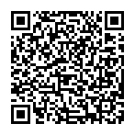

Start with Why
What should  YOU  know? | Course Description  Following the Lead On, University Strategic Plan Pillar to "Empower Students for a Life of Success, Meaning, and Impact," this interprofessional first of a two-part series of interprofessional educational sessions (APD) will engage students in education related to the IPEC Core Competencies for Interprofessional Collaborative Practice including: roles and responsibilities, and communication. Students will be assigned to an interprofessional student team and will participate in a variety of active learning assignments under the guidance of a team facilitator.  Why is IPE prevalent at all academic health centers nationwide?  National accreditation bodies have adopted interprofessional education as a method of teaching collaboration among health sciences learners with the intention of creating a team-ready workforce. Team-readiness is sought to improve employee communication, reduce unnecessary safety errors – a leading cause of harm to patients – and subsequently improve health outcomes.
 | A special thank you to our facilitators!  Whether this is your first time, or your tenth time, your impact is significant. Your students today will remember you for years to come.  Thank you for your time, your expertise, and your willingness to guide learners from across campus. We couldn’t do IPE without you!


Facilitator Expectations

Staff Contact: Margaret Robinson
Phone: 405-822-3716
Please Text

Before the Session
- Log-in early to zoom using link provided by
Margaret Robinson:
  - Test Audio
  - Test Speaker
  - Test Microphone
- Have Facilitator Instructions either open
on computer or printed for access.

During the Session
FACILITATOR:
THE GUIDE
ON THE SIDE
- You will be placed in a breakout room with students from multiple professions.
- Facilitate team activities.
  - Instructions included on following pages.
- Goal: Ensure all students are participating and answer any questions.
- Alert the zoom host of any issues or questions.
Tip: Facilitators get to guide their teams in APD activities. You don’t have to lecture today.

After the Session
- Facilitators complete evaluation at https://bbmc.ouhsc.edu/redcap/surveys/?s=KK7DD99DYXWXPXJ8
- Contact Margaret-Robinson@ou.edu with any feedback or highlights.

Facilitator Tips: General
 | Stay engaged and model strong participation |  | Enforce time limits
 | Clarify objectives of activity  (Objective box on each direction sheet) |  | Refocus conversations not pertinent to task
 | Remain neutral |  | Deal constructively – and promptly – to conflict
 | Let students know they will be called on in advance |  | Silence is okay. Student responses may be slower on zoom.
 | Round-robin responses to allow everyone time to speak |  | Mute mice or limit background noise when not speaking.

 Tips
Student has poor audio? | Ask them to participate using the chat. Read their responses to the team.
Student has poor video? | Verify they are present. Allow them to participate with their camera off.
Student is not participating? | Alert the student that you will be coming to them next to respond to a question. Advance notice builds psychological safety and encourages participation.
You’ve run out of questions? | Consider additional case study examples or ethics discussions that could facilitate general discussion with early career learners. Please keep your team engaged!

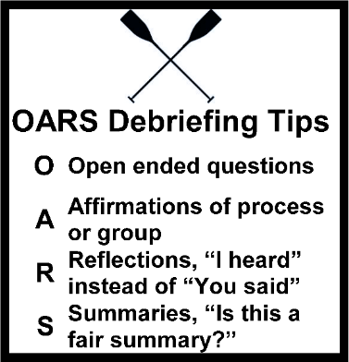
“OARS” Debriefing Process
Facilitator Tip: This technique can be used to guide your discussions with students after an activity.
O | Open ended questions (examples included with activities)
A | Affirmations of process or group
R | Reflections, “I heard” instead of “You said”
S | Summaries, “Is this a fair summary?”

Beginning of Session

A video will be played in the main zoom room reviewing the information on the next few pages. Facilitators do not need to do anything at this time.

Student Information

Definitions


Interprofessional Education
“Interprofessional education occurs when students from two or more professions learn about, from, and with each other to enable effective collaboration and improve health outcomes.”
World Health Organization. (‎2010)‎. Framework for action on interprofessional education and collaborative practice. World Health Organization. https://apps.who.int/iris/handle/10665/70185

IPEC Core Competencies
Learning Objective:
- Define the IPEC Core Competencies

Roles & Responsibilities

“Using the knowledge of one’s own role and team members’ expertise to address individual and population health outcomes.”

Communication
“Communicate in a responsive, responsible, respectful, and compassionate manner with team members.”

Values & Ethics
“Working with team members to maintain a climate of shared values, ethical conduct, and mutual respect.”

Teams & Teamwork
“Applying values and principles of the science of teamwork to adapt one’s own role in a variety of team settings.”

Interprofessional Education Collaborative. (2023). IPEC Core Competencies for Interprofessional Collaborative Practice: Version 3. Washington, DC: Interprofessional Education Collaborative. https://www.ipecollaborative.org/ipec-core-competencies

Student Information Continued

Team Formation
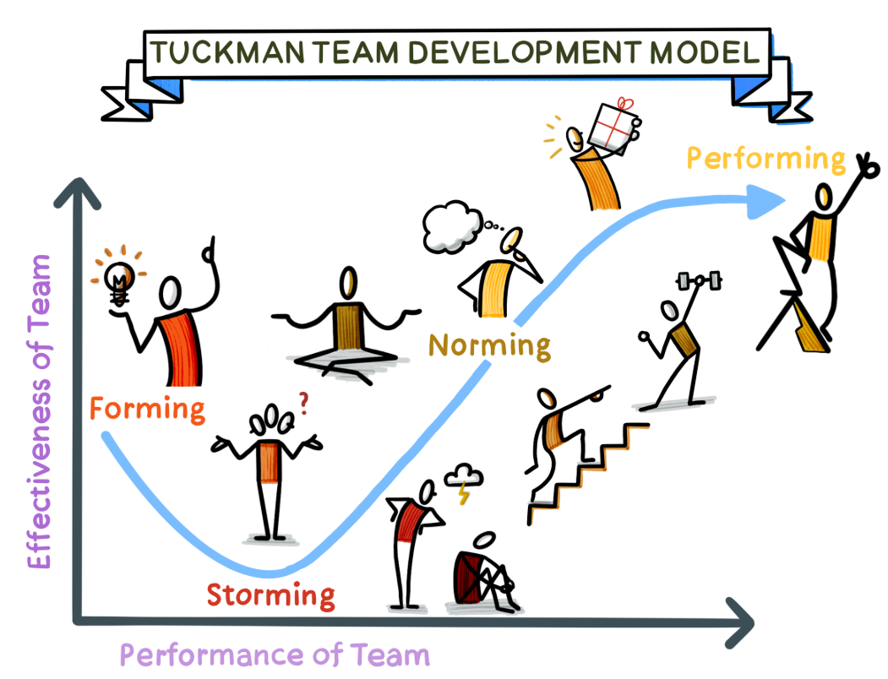
https://www.thevisualfacilitator.co.uk/blog/tuckmans-model-of-team-development

OFTEN MISSED | - Forming: The team comes together and begins to understand its goals and objectives. There may be uncertainty and some initial discomfort as team members get to know each other.
OFTEN MISSED | - Storming: Conflict arises as team members begin to establish their roles and responsibilities. This stage can be uncomfortable, but it’s important for team members to voice their opinions and work through any disagreements.
OFTEN MISSED | - Norming: The team begins to establish a sense of cohesion and unity. Team members understand each other’s strengths and weaknesses, and they work together to achieve their goals.
COMMON TEAMING | - Performing: The team is fully functional and able to work efficiently and effectively. Team members trust each other and are committed to achieving their objectives.
COMMON TEAMING | - Adjourning: The team is disbanded, either because the project has been completed or because the team members have moved on to other projects.

Rapid Team Formation
Requires we stop and quickly:
- Make sure we know who is on the team
- Confirm everyone knows the goal
- Confirm everyone knows their tasks
- Use team communication skills

Teamwork & Ethics

MORAL Model of Ethical Decision-Making
M | Massage the Dilemma | - Collect all data  - Identify related laws, ethics, and policies
O | Outline Options | - Identify Options and consequences  - Try to have at least three options
R | Review Criteria and Resolve | - Recognize best and worst case scenarios  - Find applicable ethics and laws for each option
A | Affirm Decision and Act | - Make a decision  - Act on the decision
L | Look Back | - Evaluate success, values, and ethics  - Identify what should be different in future
Thompson, D. (2023). Nursing Ethics and Theory: A Synergistic Approach to Ethical Decision-Making. https://www.rroij.com/open-access/nursing-ethics-and-theory-a-synergistic-approach-to-ethical-decisionmaking.pdf

Ethical Frameworks
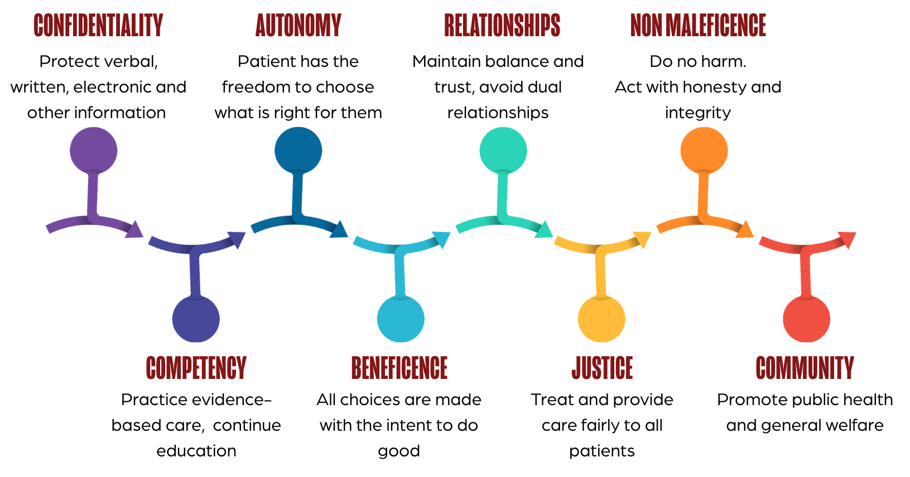

Codes of Ethics

1. Confidentiality
Audiology | Principle 3: Members shall maintain the confidentiality of the information and records of those receiving services or involved in research.  Rule 3a: Individuals shall not reveal to unauthorized persons any professional or personal information obtained from the person served professionally, unless required by law.
Dentistry | Section 1.B. Patient Records. Dentists are obliged to safeguard the confidentiality of patient records. Dentists shall maintain patient records in a manner consistent with the protection of the welfare of the patient. Upon request of a patient or another dental practitioner, dentists shall provide any information in accordance with applicable law that will be beneficial for the future treatment of that patient.
Dietitian | 10. The dietetics practitioner protects confidential information and makes full disclosure about any limitations on his or her ability to guarantee full confidentiality.
Nuclear Medicine | Professional Performance Standard Principle 3: The Nuclear Medicine Technologist will maintain strict patient confidentiality in accordance with state and federal regulations.
Nursing | 3.1. The need for health care does not justify unwanted, unnecessary, or unwarranted intrusion into a person’s life. Nurses safeguard the right to privacy for individuals, families, and communities.
Occupational Therapist | Principle 3. Standard H. Maintain the confidentiality of all verbal, written, electronic, augmentative, and nonverbal communications, in compliance with applicable laws, including all aspects of privacy laws and exceptions thereto (e.g., Health Insurance Portability and Accountability Act [Pub. L. 104–191], Family Educational Rights and Privacy Act [Pub. L. 93–380]).
Pharmacist | Principle II. A pharmacist places concern for the well-being of the patient at the center of professional practice. In doing so, a pharmacist considers needs stated by the patient as well as those defined by health science. A pharmacist is dedicated to protecting the dignity of the patient. With a caring attitude and a compassionate spirit, a pharmacist focuses on serving the patient in a private and confidential manner.
Physical Therapist | Principle 2E. Physical therapists shall protect confidential patient/ client information and may disclose confidential information to appropriate authorities only when allowed or as required by law.
Physician | IV. A physician shall respect the rights of patients, colleagues, and other health professionals, and shall safeguard patient confidences and privacy within the constraints of the law.
Physician Assistant | Pg. 6-7. Physician assistants should maintain confidentiality. By maintaining confidentiality, PAs respect patient privacy and help to prevent discrimination based on medical conditions. If patients are confident that their privacy is protected, they are more likely to seek medical care and more likely to discuss their problems candidly.
Public Health | 10. Public health institutions should protect the confidentiality of information that can bring harm to an individual or community if made public. Exceptions must be justified on the basis of the high likelihood of significant harm to the individual or others.
Radiation Therapy | Professional Performance Standard 5. General Criteria 5. Respects the patient’s right to privacy and confidentiality.
Radiography | Professional Performance Standard 5. General Criteria 5. Respects the patient’s right to privacy and confidentiality.
Social Worker | Section 1.07 Privacy and Confidentiality  (a) Social workers should respect clients' right to privacy. Social workers should not solicit private information from or about clients except for compelling professional reasons. Once private information is shared, standards of confidentiality apply.
Sonography | Professional Performance Standard Principle I. E. Maintain confidentiality of acquired patient information, and follow national patient privacy regulations as required by the "Health Insurance Portability and Accountability Act of 1996 (HIPAA)."
Speech Language Pathologist | Principle I: Rule O. Individuals shall protect the confidentiality and security of records of professional services provided, research and scholarly activities conducted, and products dispensed. Access to these records shall be allowed only when doing so is necessary to protect the welfare of the person or of the community, is legally authorized, or is otherwise required by law. Rule P. Individuals shall protect the confidentiality of any professional or personal information about persons served professionally or participants involved in research and scholarly activities and may disclose confidential information only when doing so is necessary to protect the welfare of the person or of the community, is legally authorized, or is otherwise required by law.

2. Self Determination / Autonomy
Audiology | Principle 1: Members shall provide professional services and conduct research with honesty and compassion, and shall respect the dignity, worth, and rights of those served.
Dentistry | Section 1 Principle: Patient Autonomy (“self-governance”). The dentist has a duty to respect the patient’s rights to self-determination and confidentiality.
Dietitian | 5. The dietetics practitioner provides professional services with objectivity and with respect for the unique needs and values of individuals.
Nuclear Medicine | Professional Performance Standard Principle 1: The Nuclear Medicine Technologist will provide services with compassion and respect for the dignity of the individual and with the intent to provide the highest quality of patient care.
Nursing | 1.4 The Right to Self-Determination. Respect for human dignity requires the recognition of specific patient rights, in particular, the right to self-determination. Patients have the moral and legal right to determine what will be done with and to their own person; to be given accurate, complete, and understandable information in a manner that facilitates an informed decision; and to be assisted with weighing the benefits, burdens, and available options in their treatment, including the choice of no treatment.
Occupational Therapist | Principle 3. Occupational therapy personnel shall respect the right of the individual to self-determination, privacy, confidentiality, and consent.
Pharmacist | III. A pharmacist respects the autonomy and dignity of each patient. A pharmacist promotes the right of self-determination and recognizes individual self-worth by encouraging patients to participate in decisions about their health. A pharmacist communicates with patients in terms that are understandable. In all cases, a pharmacist respects personal and cultural differences among patients.
Physical Therapist | Principle #1: Physical therapists shall respect the inherent dignity and rights of all individuals.
Physician | I. A physician shall be dedicated to providing competent medical care, with compassion and respect for human dignity and rights.
Physician Assistant | Page 3. Autonomy, strictly speaking, means self-rule. Patients have the right to make autonomous decisions and choices, and physician assistants should respect these decisions and choices.
Public Health | 4. Public health should advocate and work for the empowerment of disenfranchised community members, aiming to ensure that the basic resources and conditions necessary for health are accessible to all.
Radiation Therapy | Professional Performance Standard 5. General Criteria 1. Provides health care services with consideration for a diverse patient population.
Radiography | Professional Performance Standard 5. General Criteria 1. Provides health care services with consideration for a diverse patient.
Social Worker | 1.02 Self-Determination. Social workers respect and promote the right of clients to self-determination and assist clients in their efforts to identify and clarify their goals. Social workers may limit clients' right to self-determination when, in the social workers' professional judgment, clients' actions or potential actions pose a serious, foreseeable, and imminent risk to themselves or others.
Sonography | Professional Performance Standard Principle I. B. Respect the patient's autonomy and the right to refuse the procedure.
Speech Language Pathologist | Principle I. Individuals shall honor their responsibility to hold paramount the welfare of persons they serve professionally or who are participants in research and scholarly activities, and they shall treat animals involved in research in a humane manner.

3. Relationship with Clients / Patients
Audiology | Principle 1. Rule 1b: Individuals shall not provide services except in a professional relationship, and shall not discriminate in the provision of services to individuals on the basis of sex, race, religion, national origin, sexual orientation, or general health.
Dentistry | 2.G. Personal Relationships with Patients. Dentists should avoid interpersonal relationships that could impair their professional judgment or risk the possibility of exploiting the confidence placed in them by a patient.
Dietitian | 9. The dietetics practitioner treats clients and patients with respect and consideration.
Nuclear Medicine | Professional Performance Standard Principle 2: The Nuclear Medicine Technologist will provide care without discrimination regarding the nature of the illness or disease, gender, race, religion, sexual preference or socioeconomic status of the patient.
Nursing | 1.2 Relationships with Patients. Nurses establish relationships of trust and provide nursing services according to need, setting aside any bias or prejudice.
Occupational Therapist | Principle 2.F. Avoid dual relationships, conflicts of interest, and situations in which a practitioner, educator, student, researcher, or employer is unable to maintain clear professional boundaries or objectivity
Pharmacist | I. A pharmacist respects the covenantal relationship between the patient and pharmacist. Considering the patient-pharmacist relationship as a covenant means that a pharmacist has moral obligations in response to the gift of trust received from society. In return for this gift, a pharmacist promises to help individuals achieve optimum benefit from their medications, to be committed to their welfare, and to maintain their trust.
Physical Therapist | Principle #4: Physical therapists shall demonstrate integrity in their relationships with patients/clients, families, colleagues, students, research participants, other health care providers, employers, payers, and the public.
Physician | II. A physician shall uphold the standards of professionalism, be honest in all professional interactions, and strive to report physicians deficient in character or competence, or engaging in fraud or deception, to appropriate entities.
Physician Assistant | Page 9. Such relationships generally are unethical because of the PA’s position of authority and the inherent imbalance of knowledge, expertise, and status. Issues such as dependence, trust, transference, and inequalities of power may lead to increased vulnerability on the part of the current or former patients or key third parties.
Public Health | Principle 2. Positive relationships among individuals and positive collaborations among institutions are signs of a healthy community. The rightful concern for the physical individuality of humans and one’s right to make decisions for oneself must be balanced against the fact that each person’s actions affect other people.
Radiation Therapy | Professional Performance Standard 5. General Criteria 2. Acts as a patient advocate.
Radiography | Professional Performance Standard 5. General Criteria 2. Acts as a patient advocate.
Social Worker | 1.06.(c) Social workers should not engage in dual or multiple relationships with clients or former clients in which there is a risk of exploitation or potential harm to the client. In instances when dual or multiple relationships are unavoidable, social workers should take steps to protect clients and are responsible for setting clear, appropriate, and culturally sensitive boundaries. (Dual or multiple relationships occur when social workers relate to clients in more than one relationship, whether professional, social, or business. Dual or multiple relationships can occur simultaneously or consecutively.)
Sonography | Professional Performance Standard Principle I. C. Recognize the patient's individuality and provide care in a non-judgmental and non-discriminatory manner.
Speech Language Pathologist | Principle IV. Individuals shall uphold the dignity and autonomy of the professions, maintain collaborative and harmonious interprofessional and intraprofessional relationships, and accept the professions' self-imposed standards.

4. Non-Maleficence
Audiology | Principle 4. Members shall provide only services and products that are in the best interest of those served.
Dentistry | II. Qualities of honesty, compassion, kindness, integrity, fairness and charity are part of the ethical education of a dentist and practice of dentistry and help to define the true professional. As such, each dentist should share in providing advocacy to and care of the underserved. I
Dietitian | 1. The dietetics practitioner conducts himself/herself with honesty, integrity, and fairness.
Nuclear Medicine | Professional Performance Standard Principle 6: The Nuclear Medicine Technologist will not engage in fraud, deception, or criminal activities.
Nursing | 5.4. Personal integrity is an aspect of wholeness of character that requires reflection and discernment; its maintenance is a self-regarding duty.
Occupational Therapist | Principle 6. Occupational therapy personnel shall treat clients, colleagues, and other professionals with respect, fairness, discretion, and integrity.
Pharmacist | IV. A pharmacist acts with honesty and integrity in professional relationships. A pharmacist has a duty to tell the truth and to act with conviction of conscience. A pharmacist avoids discriminatory practices, behavior or work conditions that impair professional judgment, and actions that compromise dedication to the best interests of patients.
Physical Therapist | Principle #3: Physical therapists shall be accountable for making sound professional judgments.
Physician | I. A physician shall be dedicated to providing competent medical care, with compassion and respect for human dignity and rights.
Physician Assistant | Page 4. Physician assistants hold as their primary responsibility the health, safety, welfare, and dignity of all human beings.
Public Health | 11. Public health institutions should ensure the professional competence of their employees.
Radiation Therapy | Professional Performance Standard 5. General Criteria 3. Accepts accountability for decisions made and actions taken.
Radiography | Professional Performance Standard 5. General Criteria 3. Accepts accountability for decisions made and actions taken.
Social Worker | 5.01 Integrity of the Profession. (a) Social workers should work toward the maintenance and promotion of high standards of practice.
Sonography | Professional Performance Standard Principle III: To promote professional integrity and public trust, the diagnostic medical sonographer shall: A. Be truthful and promote appropriate communications with patients and colleagues. B. Respect the rights of patients, colleagues and yourself. Etc.
Speech Language Pathologist | Principle of Ethics IV. Individuals shall uphold the dignity and autonomy of the professions, maintain collaborative and harmonious interprofessional and intraprofessional relationships, and accept the professions' self-imposed standards.

5. Professional Growth and Competence
Audiology | Principle 2: Members shall maintain the highest standards of professional competence in rendering services.
Dentistry | 2.A. Education. The privilege of dentists to be accorded professional status rests primarily in the knowledge, skill and experience with which they serve their patients and society. All dentists, therefore, have the obligation of keeping their knowledge and skill current.
Dietitian | 14. The dietetics practitioner assumes a life-long responsibility and accountability for personal competence in practice, consistent with accepted professional standards, continually striving to increase professional knowledge and skills and to apply them in practice.
Nuclear Medicine | Professional Performance Standard Principle 5: The Nuclear Medicine Technologist will continually strive to improve their knowledge and technical skills.
Nursing | 5.5. Nurses must maintain competence and strive for excellence in their nursing practice, whatever the role or setting. Professional growth requires a commitment to lifelong learning.
Occupational Therapist | Principle 1.G. Maintain competency by ongoing participation in education relevant to one’s practice area.
Pharmacist | V. A pharmacist maintains professional competence. A pharmacist has a duty to maintain knowledge and abilities as new medications, devices, and technologies become available and as health information advances.
Physical Therapist | Principle #6: Physical therapists shall enhance their expertise through the lifelong acquisition and refinement of knowledge, skills, abilities, and professional behaviors.
Physician | II. A physician shall uphold the standards of professionalism, be honest in all professional interactions, and strive to report physicians deficient in character or competence, or engaging in fraud or deception, to appropriate entities.
Physician Assistant | Page 9. Competency Physician assistants should commit themselves to providing competent medical care and extend to each patient the full measure of their professional ability as dedicated, empathetic health care providers. PAs should also strive to maintain and increase the quality of their health care knowledge, cultural sensitivity, and cultural competence through individual study and continuing education.
Public Health | 11. Public health institutions should ensure the professional competence of their employees.
Radiation Therapy | Professional Performance Standard 3. The radiation therapist acquires and maintains current knowledge in practice.
Radiography | Professional Performance Standard 3. The radiographer acquires and maintains current knowledge in practice.
Social Worker | 1.04 Competence. (a) Social workers should provide services and represent themselves as competent only within the boundaries of their education, training, license, certification, consultation received, supervised experience, or other relevant professional experience.
Sonography | Professional Performance Standard Principle II: To promote the highest level of competent practice, diagnostic medical sonographers shall: A. Obtain appropriate diagnostic medical sonography education and clinical skills to ensure competence.
Speech Language Pathologist | Principle of Ethics II. Individuals shall honor their responsibility to achieve and maintain the highest level of professional competence and performance.

6. Beneficence
Audiology | Principle 7: Members shall honor their responsibilities to the public and to professional colleagues. Rule 7a: Individuals shall not use professional or commercial affiliations in any way that would limit services to or mislead patients or colleagues. Rule 7b: Individuals shall inform colleagues and the public in an objective manner consistent with professional standards about products and services they have developed or research they have conducted.
Dentistry | Dentists shall be obliged to seek consultation, if possible, whenever the welfare of patients will be safeguarded or advanced by utilizing those who have special skills, knowledge, and experience.
Dietitian | 19. The dietetics practitioner demonstrates respect for the values, rights, knowledge, and skills of colleagues and other professionals.
Nuclear Medicine | Professional Performance Standard Principle 7: The Nuclear Medicine Technologist will be an advocate for their profession.
Nursing | 1.5. Respect for persons extends to all individuals with whom the nurse interacts. Nurses maintain professional, respectful, and caring relationships with colleagues and are committed to fair treatment, transparency, integrity-preserving compromise, and the best resolution of conflicts.
Occupational Therapist | Principle 6. Occupational therapy personnel shall treat clients, colleagues, and other professionals with respect, fairness, discretion, and integrity.
Pharmacist | VI. A pharmacist respects the values and abilities of colleagues and other health professionals. When appropriate, a pharmacist asks for the consultation of colleagues or other health professionals or refers the patient. A pharmacist acknowledges that colleagues and other health professionals may differ in the beliefs and values they apply to the care of the patient.
Physical Therapist | Principle #4: Physical therapists shall demonstrate integrity in their relationships with patients/clients, families, colleagues, students, research participants, other health care providers, employers, payers, and the public.
Physician | IV. A physician shall respect the rights of patients, colleagues, and other health professionals, and shall safeguard patient confidences and privacy within the constraints of the law.
Physician Assistant | Page 10. Physician assistants should be committed to working collegially with other members of the health care team to assure integrated, well-managed, and effective care of patients. PAs should strive to maintain a spirit of cooperation with other health care professionals, their organizations, and the general public.
Public Health | 12. Public health institutions and their employees should engage in collaborations and affiliations in ways that build the public’s trust and the institution’s effectiveness.
Radiation Therapy | Professional Performance Standard 4. The radiation therapist promotes a positive and collaborative practice atmosphere with other members of the health care team.
Radiography | Professional Performance Standard 4. The radiographer promotes a positive and collaborative practice atmosphere with other members of the health care team.
Social Worker | 2.01 Respect. (a) Social workers should treat colleagues with respect and should represent accurately and fairly the qualifications, views, and obligations of colleagues. (b) Social workers should avoid unwarranted negative criticism of colleagues in verbal, written, and electronic communications with clients or with other professionals. Unwarranted negative criticism may include demeaning comments that refer to colleagues' level of competence or to individuals' attributes such as race, ethnicity, national origin, color, sex, sexual orientation, gender identity or expression, age, marital status, political belief, religion, immigration status, and mental or physical ability. (c) Social workers should cooperate with social work colleagues and with colleagues of other professions when such cooperation serves the well-being of clients.
Sonography | Professional Performance Standard Principle III: To promote professional integrity and public trust, the diagnostic medical sonographer shall: A. Be truthful and promote appropriate communications with patients and colleagues. B. Respect the rights of patients, colleagues and yourself., etc.
Speech Language Pathologist | Principle of Ethics IV. Individuals shall uphold the dignity and autonomy of the professions, maintain collaborative and harmonious interprofessional and intraprofessional relationships, and accept the professions' self-imposed standards.

7. Justice (Law)
Audiology | Rule 1b: Individuals shall not provide services except in a professional relationship, and shall not discriminate in the provision of services to individuals on the basis of sex, race, religion, national origin, sexual orientation, or general health.
Dentistry | Section 4. This principle expresses the concept that professionals have a duty to be fair in their dealings with patients, colleagues and society. Under this principle, the dentist’s primary obligations include dealing with people justly and delivering dental care without prejudice. In its broadest sense, this principle expresses the concept that the dental profession should actively seek allies throughout society on specific activities that will help improve access to care for all.
Dietitian | 4. The dietetics practitioner complies with all laws and regulations applicable or related to the profession or to the practitioner’s ethical obligations as described in this Code.
Nuclear Medicine | Professional Performance Standard Principle 2: The Nuclear Medicine Technologist will provide care without discrimination regarding the nature of the illness or disease, gender, race, religion, sexual preference or socioeconomic status of the patient.
Nursing | 1.4. Nurses have an obligation to be familiar with and to understand the moral and legal rights of patients. Nurses preserve, protect, and support those rights by assessing the patient’s understanding of the information presented and explaining the implications of all potential decisions.
Occupational Therapist | Principle 4. The Principle of Justice relates to the fair, equitable, and appropriate treatment of persons (Beauchamp & Childress, 2013). Occupational therapy personnel should relate in a respectful, fair, and impartial manner to individuals and groups with whom they interact. They should also respect the applicable laws and standards related to their area of practice. Justice requires the impartial consideration and consistent following of rules to generate unbiased decisions and promote fairness. As occupational therapy personnel, we work to uphold a society in which all individuals have an equitable opportunity to achieve occupational engagement as an essential component of their life.
Pharmacist | IV. A pharmacist acts with honesty and integrity in professional relationships. A pharmacist has a duty to tell the truth and to act with conviction of conscience. A pharmacist avoids discriminatory practices, behavior or work conditions that impair professional judgment, and actions that compromise dedication to the best interests of patients.
Physical Therapist | Principle #8: Physical therapists shall participate in efforts to meet the health needs of people locally, nationally, or globally.
Physician | III. A physician shall respect the law and also recognize a responsibility to seek changes in those requirements which are contrary to the best interests of the patient.
Physician Assistant | Page 3. Justice means that patients in similar circumstances should receive similar care. Justice also applies to norms for the fair distribution of resources, risks, and costs.  Page 4. Physician assistants uphold the tenets of patient autonomy, beneficence, nonmaleficence, and justice.
Public Health | 4. Public health should advocate and work for the empowerment of disenfranchised community members, aiming to ensure that the basic resources and conditions necessary for health are accessible to all.
Radiation Therapy | Professional Performance Standard 5. General Criteria 4. Delivers patient care and service free from bias or discrimination.
Radiography | Professional Performance Standard 5. General Criteria 4. Delivers patient care and service free from bias or discrimination.
Social Worker | 6.01 Social Welfare. Social workers should promote the general welfare of society, from local to global levels, and the development of people, their communities, and their environments. Social workers should advocate for living conditions conducive to the fulfillment of basic human needs and should promote social, economic, political, and cultural values and institutions that are compatible with the realization of social justice.
Sonography | Professional Performance Standard Principle III. E. Promote equitable access to care.
Speech Language Pathologist | Principle I.C. Individuals shall not discriminate in the delivery of professional services or in the conduct of research and scholarly activities on the basis of race, ethnicity, sex, gender identity/gender expression, sexual orientation, age, religion, national origin, disability, culture, language, or dialect.

8. Community or Social Needs
Audiology | Principle 1: Members shall provide professional services and conduct research with honesty and compassion, and shall respect the dignity, worth, and rights of those served.
Dentistry | 3.A. Community Service. Since dentists have an obligation to use their skills, knowledge and experience for the improvement of the dental health of the public and are encouraged to be leaders in their community, dentists in such service shall conduct themselves in such a manner as to maintain or elevate the esteem of the profession.
Dietitian | 3. The dietetics practitioner considers the health, safety, and welfare of the public at all times. The dietetics practitioner will report inappropriate behavior or treatment of a client by another dietetics practitioner or other professionals.
Nuclear Medicine | Inherent, not stipulated.
Nursing | Provision 8: The nurse collaborates with other health professionals and the public to protect human rights, promote health diplomacy, and reduce health disparities.
Occupational Therapist | Principle 4. B) Assist those in need of occupational therapy services in securing access through available means. C) Address barriers in access to occupational therapy services by offering or referring clients to financial aid, charity care, or pro bono services within the parameters of organizational policies.
Pharmacist | VII. A pharmacist serves individual, community, and societal needs. The primary obligation of a pharmacist is to individual patients. However, the obligations of a pharmacist may at times extend beyond the individual to the community and society. In these situations, the pharmacist recognizes the responsibilities that accompany these obligations and acts accordingly.
Physical Therapist | Principle #8: Physical therapists shall participate in efforts to meet the health needs of people locally, nationally, or globally.
Physician | VII. A physician shall recognize a responsibility to participate in activities contributing to the improvement of the community and the betterment of public health.
Physician Assistant | Page 12. Community Well Being Physician assistants should work for the health, well being, and the best interest of both the patient and the community. Sometimes there is a dynamic moral tension between the well being of the community in general and the individual patient. Conflict between an individual patient’s best interest and the common good is not always easily resolved. In general, PAs should be committed to upholding and enhancing community values, be aware of the needs of the community, and use the knowledge and experience acquired as professionals to contribute to an improved community.
Public Health | 2. Public health should achieve community health in a way that respects the rights of individuals in the community.  3. Public health policies, programs, and priorities should be developed and evaluated through processes that ensure an opportunity for input from community members.  4. Public health should advocate and work for the empowerment of disenfranchised community members, aiming to ensure that the basic resources and conditions necessary for health are accessible to all.
Radiation Therapy | Clinical Performance Standard 1. 6. Recognizes the patient’s need for referral to other care providers such as a social worker, nurse or dietitian.
Radiography | Clinical Performance Standard 5.6. Adheres to the established practice standards of the profession.
Social Worker | 6.01 Social Welfare. Social workers should promote the general welfare of society, from local to global levels, and the development of people, their communities, and their environments. Social workers should advocate for living conditions conducive to the fulfillment of basic human needs and should promote social, economic, political, and cultural values and institutions that are compatible with the realization of social justice.
Sonography | Inherent, not stipulated.
Speech Language Pathologist | The ASHA Code of Ethics is intended to ensure the welfare of the consumer and to protect the reputation and integrity of the professions.

Effective Communication
- Complete. Communicate all relevant information.
- Clear. Convey information in plain language.
- Brief. Communicate information in a concise manner.
- Timely. Offer and request information in an appropriate timeframe.
- Respectful. Use communication to foster psychological safety and affirm other team members, not just to give instructions or share information.

Zoom Activity Professionalism
APD2 is assessed by participation. Facilitators will be monitoring and reporting participation for attendance. Participation in a professional zoom environment is similar to classroom expectations.
Students are expected to be present, to participate, and to be respectful of their colleagues.



 | You will be automatically assigned to a breakout room.  - Be ready to start with activity #1.  - Instructions follow on the next page.  - You may screenshare to make it easy.  - Stay in the breakout room until the JTOG evaluation at the end.

Facilitator Tips: Activity #1

See next page for the Activity #1 Worksheet to share with students.
Start  Here | - Set timer for 10 minutes.  - Introduce yourself and your background.  - Ask team members to introduce themself
 | - Share screen with Activity #1 Worksheet (next page)  – or ask a student participant to be the notetaker.
Set Expectations | - A team charter is similar to how any group-work assignment starts  - This is an easy assignment while everyone gets comfortable and their zoom audio gets connected  - No right or wrong answers  - Everyone should contribute something  - These will be the rules of the road for the rest of the session
GOAL | - Rapid team formation steps: forming, storming, and norming. Performing will be in Activities #2-4.  - Focus on getting comfortable with the situation, setting team goals.
Deliverable | - A list of Team Goals and Communication Agreements
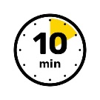 | - Keep engaged for 10 minutes. Suggestions if you finish early:  - Use round-robin technique to get feedback from all participants  - When ready, move on to the next Activity
End | - At time, a note will appear at the top of the screen.  - Move on to Activity #2

Activity #1: Rapid Team Formation/Team Goals

Instructions:
Learning Objective:
- Apply steps of rapid team formation to outline team goals for remainder of class
- Make sure everyone has their camera and microphone on.
- Facilitator will share screen and take notes (or another student can).
- Introduce yourself, your college and degree program, and where you’re from.
- As a team, decide your goals and communication agreements for today. A few examples are provided.

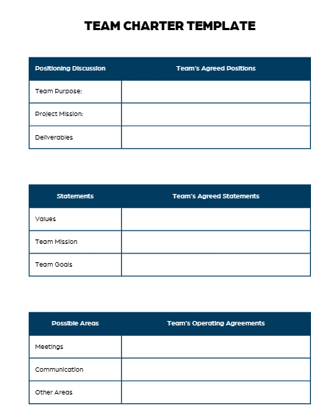
Team Goal Examples:
- Complete all tasks on time
- Complete all tasks with quality
- Complete all tasks above and beyond
- Apply critical knowledge and the best of our training to the task
- All members have critical knowledge

Team Communication Examples:
- All members take turns speaking
- No one speaks over anyone else
- Use respectful language
- We’ll report anyone not participating back to their program

Team Goals

Team Operating Agreements: Communication

Facilitator Tips: Activity #2

See next page for the Activity #2 Worksheet to share with students.
Start Here | - Set timer for 15 minutes.  - Download slide deck at: APD2 Activity #2 Slide Deck
 | - Share screen with APD2 Activity #2 Slide Deck
Set Expectations | - All students should participate  - No one will be graded. There are no wrong answers.
GOAL | - Compare and contrast the distinct professional cultures, values, roles, responsibilities, and ethical obligations of health professions involved in interprofessional care
Deliverable | - Complete the ethics challenge with team participation
Guide on the Side | - You can read the questions out loud for those using smaller screens  - You do not have to make decisions for the team  - Quite pauses can be purposeful to allow thinking  - Engage students to use the chat or call on them with advanced notice
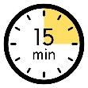 | - Keep engaged for 15 minutes. Suggestions if you finish early:  - Use the debrief questions on the next page
End | - At time, a note will appear at the top of the screen.  - Stay in your breakout room  - A Video for Activity #3 will automatically play at 10:40 AM / 1:10 PM

Activity #2: Navigating Ethics Activity

Instructions
Learning Objective:
- Compare and contrast the distinct professional cultures, values, roles, responsibilities, and ethical obligations of health professions involved in interprofessional care
- Use the code of ethics materials in your packet
- Facilitator will share screen
- All team members must discuss each decision.
- If time permits, review the debrief questions below as a team.
- The next video will automatically play at the time on the agenda.

Case Scenario
Omar is a 17-year-old male who is seen for a chronic illness. When meeting with him individually, he discloses considering an herbal supplement known to cause opioid- and stimulant-like effects. He read about it online. It does not have evidence supporting its use or sufficient safety data available.
PATH A: Confidentiality

You promise Omar to keep his secret.
PATH B:
Duty to Warn

You express concern about the unproven treatments and urge Omar to consider safer options, consult parents.
Crossroads:
Confidentiality vs.
Duty to Warn
Duty to Warn

Team Facilitator will present additional activity crossroads.

Debrief  Corner | - If Omar’s chronic condition were life-threatening, would that alter your decision path? What if it were a communicable disease?  - What ethical principles (from the Code of Ethics Document) seemed to be the most challenging to uphold in this situation?  - How can understanding different perspectives (i.e. the patient's, parent’s, or professional’s) affect your choices?  - How should Omar’s disclosure be communicated to the rest of the team, and what information should be shared or limited?  - How can the team ensure consistent messaging so Omar does not receive conflicting advice?  - Which of the 8 tenants of ethics did we miss in this discussion?  - How does interprofessional collaboration reduce ethical risk in cases like this?

Facilitator Tips: Activity #3

See next page for the Activity #3 Worksheet to share with students.
- A Video for Activity #3 will automatically play at
10:40 AM / 1:10 PM
Start Here | - After the video, set timer for 25 minutes.
- Share screen with Activity #3 Worksheet (next page)
– or ask a student participant to be the notetaker.
Set Expectations | - All students should participate  - No one will be graded. There are no wrong answers.  - Focus on team communication, not the patient or the case  - Keep discussion generic, most learners are just getting started in their programs.  - Use debrief questions to guide reflective learning
GOAL | - Integrate the expertise of other professions to evaluate and inform care decisions that align with patient and community values, priorities, and preferences.
Deliverable | - A successful team huddle discussion
Guide on the Side | - Lead group discussion, allow everyone to contribute.  - Start with question one, come to consensus, then move on to the next section.  - Consider providing context or additional details about the Social Determinants of Health or Healthcare Ethics, as needed
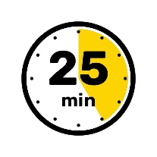 | - Keep engaged for 25 minutes. Suggestions if you finish early:  - Use round-robin technique to get feedback from all participants  - Ask pointed questions to involve all professions, such as what is the role of research
End | - A Video for Activity #4 will automatically play at  11:10 AM / 1:40 PM

Activity #3: Team Huddle Case Study

Instructions
Learning Objective:
- Integrate the expertise of other professions to evaluate and inform care decisions that align with patient and community values, priorities, and preferences.
- Video will broadcast automatically at the time on agenda.
- As a team, practice a team huddle to plan how to care for the patient at the clinic.
- Use the questions below - or come up with new questions.
- If time permits, review the debrief questions on page 23 as a team.
- The next video will automatically play at the time on the agenda.

NOTE: The goal is to practice team communication – not to know the patient health information or diagnosis.

All team members from any health science program can contribute to the discussion ranging from research, theory, prerequisite knowledge, or previous experience.

Team Huddle Worksheet
Possible Questions | Responses
- What do we know about the situation and the patient?

- Who is on our team and how can they help?

- What do we still need to know?

- What are possible supportive actions each team member can suggest?

- What ethical dilemma is developing for John and his caregiver?

- Can the patient or caregiver be integrated as a team-member to guide decision making?

- Other questions?

Activity #3 Case Script
Setting: Waiting room of a clinic. | John (patient) and Gary (caregiver) sit in chairs next to each other. John is reading a travel book, Gary is playing on his phone.  John: “Look at this. It’s that place from that show we watched. In Florida.”  Gary (looking over): “Oh yeah, the grandkids would love that. We’ll have to make sure we add that to the list.”  John (gesturing around the clinic): “Assuming these people don’t try to ruin my fun.”  Gary: “You mean by treating your cancer and saving your life?”  John: “I mean by treating my cancer and making me too tired to get out of bed, making my skin feel like it’s on fire, and making me unable to swallow solid food.” John pauses. “I think I’ve had enough to deal with already. Not sure I can take much more”  Gary (takes a deep breath): “Maybe they’ll have better options this time.”  John: “Well, they’ll need to if they want me to agree.”  Nurse: “John? Ready to come back?”  Gary rises quickly, John takes longer to get up and walks more slowly. Gary offers his arm to help as they walk.

Setting: Clinic Room | Nurse: “How are y’all today?”  John (slow to sit): “We’re alright.”  Gary: “A little anxious to know what’s going to happen next.”  Nurse (nods): “Ready to hear your options, huh?” Notices the book. “You all planning a trip?”  Gary: “Yeah, a big family trip with all the kids and grandkids. Disney World.”  Nurse: “That sounds amazing! How many grandkids do you have now?”  John: (smiles): “Nine! Ages two to eleven.”  Nurse: “Perfect time for Disney, then, huh? All right, let me go and get the team so you can talk options, okay?”

Setting: Work room. Team is reviewing John’s chart in the computer along with a medical student. | Nurse: “We have John and Gary checked in to room 10.”  PA: “How are they today?”  Nurse: “A little anxious to hear about next steps but vitals were all good as you can see in the chart.”  PA: “You worked up John?”  Student: “Yes. John is a 70-year-old M with recurrent head and neck cancer. Originally diagnosed 20 years ago treated with surgery and radiation. Recurrence 8 years ago treated with additional surgical resection and radiation. Based on recent physical exam, it appears John may be experiencing yet another recurrence. They need testing to see if they are a surgical candidate and whether their treatment plan will include chemo and radiation.”  Provider: “Very good. The plan for today is to discuss next steps and see what they are prepared to do. I’ll be here if you need me.”

Setting: Clinic room. The team enters the room after knocking. All sanitize their hands as they enter. | PA: “Hi, John, Gary. Good to see you. This is our medical student, Madeline, who’s here shadowing us for the day. How are you, John?”  John: “A little nervous.”  PA: “How about you, Gary?”  Gary: “Not too happy John has to go through this again but ready to hear what needs to happen.”  PA: “Understandable. Unfortunately, this isn’t the first time you’ve gone through this – either of you. Here’s what I’d like to do. First, we need to do some imaging to see what we’re dealing with. We’ll biopsy the tissue, then talk about the best way to treat – whether surgery, radiation, chemo, or a combination of those.”  John immediately starts shaking his head.  PA: “Tell me what you’re thinking, John.”  John looks to Gary and nudges his arm.  Gary: “You want me to…?”  John nods again.  Gary: “We’ve been talking a lot, so his voice is tired. All right. So last time, the oncologist said there wasn’t much left to resect and any further recurrences would probably have to have chemo or radiation, or both, like you said. But John cannot handle the idea of more radiation.”  PA nods.  PA (to John): “Is it okay if I share with my student some of the effects of radiation you’ve experienced?”  John nods in affirmation, seems open for student to hear.  PA: “John has been through a lot. They have structural changes that make it difficult to talk and eat. In fact, John only drinks liquids.”  Medical student: “Is that because of pain or just physical changes?”  John: “Both.”  Gary: (Nods) And he has permanent dry mouth, lost a few teeth, and things taste weird. He cannot stand the sunburn feeling from radiation, it’s really deep and painful. The skin even looks burned. On top of that, he just feels worn out”  John: “It’s too much.”  Gary: “It is too much.” He pats John’s arm.  Nurse: “I noticed you were a little slowing getting up, sitting down, and walking. Are you having some pain or stiffness?”  John: (Nods) “For a few months now. I’m alright.” He looks to Gary: “The trial?”  Gary looks to PA: “Oh, yeah, we were looking online and found a clinical trial for some sort of immunotherapy. I mean, I’m ready to do anything but John is not and we read it might have fewer side effects. Is that on the table?”  PA: “We can absolutely look at the trial and see if John meets inclusion criteria. We may need to add on additional testing. I also want to get a baseline test of your hearing based on one of the chemo agents we’re considering. Would you be okay if we started with the testing and imaging, then made plans?”  Gary and John look at each other. John nods.  John: “I also want to know how much time I have if we do nothing.”  Gary looks down, covers his eyes with his hand.  Gary: “I don’t know if we’re there yet.”  John: “I may be. I just want to hear all of the options.” Gary takes a breath, nods, and looks up.  PA. “All right. About that pain and stiffness - how about I get you in with occupational therapy and physical therapy? I can send a referral today to maybe help you out.”  John shakes his head and makes a money motion with his hands.  Gary: “We’re worried about costs. John is on disability but I’m struggling to keep my job and keep all of our appointments. I’m nervous about losing my job and we’re saving for this trip too.”  PA nods. “We can talk costs too, that’s an important factor when making these decisions. What other questions do you have?”

NOTE: | Use the Activity #3 Team Huddle Worksheet (page 18) to discuss your team’s approach. Then, use the Debrief Questions (page 23) when done.

Activity #3 Debrief Questions
The group facilitator will select from the below questions.

Reflection on Team Functioning
- What did this case illustrate about the value of interprofessional collaboration in complex, emotionally charged decisions?
- What team behaviors helped reduce the burden on any one individual team member?
- What risks might arise if this case were managed without an interprofessional approach?
- What would you do differently as a team if you encountered a similar case in practice?

Interprofessional Teamwork & Shared Problem Solving (TT3)
- How did the team respond to uncertainty (e.g., recurrence, treatment tolerance, prognosis)?
- In what ways did the team facilitate or limit shared problem solving among team members?

Use of Professional Roles, Responsibilities, and Expertise (TT4)
- Where did you see the team integrate expertise (clinical, functional, psychosocial, financial) into decision-making?
- Were there moments when a team member appropriately stayed within their scope, or when broader input might have been helpful?

Patient-Centered Care & Values Integration (TT4 + VE)
- How did the team acknowledge, validate, or explore those values during the huddle?
- How did the planned family trip influence the ethical and clinical decision-making process?

Ethical Analysis & Decision-Making
- How did the team balance avoiding harm with offering potentially beneficial options?
- What responsibilities do clinicians have when a patient may be approaching a point of treatment refusal or limits of tolerance?
- How does financial strain complicate ethical decision-making in this case?

Communication Dynamics & Power Sharing
- How did the team handle John’s reliance on Gary to speak for him?
- What are the ethical and practical considerations when a caregiver speaks on behalf of a patient?
- How could the team support both John’s autonomy and Gary’s caregiving role without creating conflict?

[Activity #4 video will play automatically at time on agenda]

Facilitator Tips: Activity #4
See next page for the Activity #4 Worksheet to share with students.
- A Video for Activity #4 will automatically play at
11:10 AM / 1:40 PM
Start Here | - After the video, set timer for 20 minutes.
- Share screen with Activity #4 Worksheet (next 2 pages)
– or ask a student participant to be the notetaker.
Set Expectations | - All students should participate  - Ask students to put CUS statements in chat.  - All students will verbally say their CUS statement. Facilitators will call on each student.  - Out of respect, keep statements to 30-45 seconds.  - Use debrief questions to guide reflective learning – Page 37
GOALS | - Describe evidence-informed processes of team development and team practices.  - Apply values and principles of the science of teamwork to adapt one's own role in a variety of team settings.  - Practice team reasoning, problem-solving, and decision-making.  - Operate from a shared framework that supports resiliency, well-being, safety, and efficacy.
Deliverable | - Successful practice of using C.U.S. statements
Guide on the Side | - Keep pacing so everyone can participate.  - Don’t provide feedback until the debrief.  - Engage students in the debrief questions.
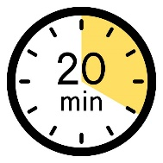 | - Keep engaged for 20 minutes. Suggestions if you finish early:  - Use round-robin technique to get feedback from all participants
End | - All teams will return to the main room for JTOG evaluation  At 11:50 AM / 2:20 PM

Activity #4: Team Science & C.U.S. Tool

Instructions
Learning Objective:
- Describe evidence-informed processes of team development and team practices.
- Apply values and principles of the science of teamwork to adapt one's own role in a variety of team settings.
- Practice team reasoning, problem-solving, and decision-making.
- Operate from a shared framework that supports resiliency, well-being, safety, and efficacy.
- Video will broadcast automatically at the time on agenda.
- Individually, write your own CUS statement
- Post your statement in breakout room chat.
- Facilitators will call on each to state their CUS statement, 30-45 seconds each.
- After everyone shares, continue to debrief questions on Page 29.
- When time is called, all teams will return to the main session for evaluation.

Content from video is also included in following pages

TeamSTEPPS C.U.S. Tool
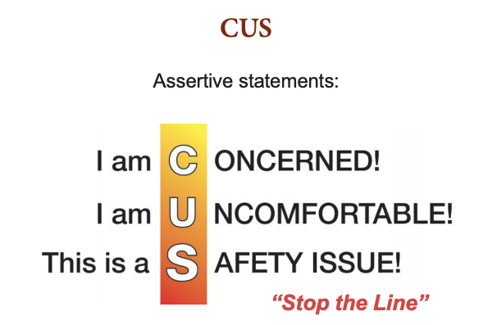
Agency for Healthcare Research and Quality. (2025). Psychological safety. In MRSA prevention toolkit: Targeting SSI psychological safety. U.S. Department of Health & Human Services. https://www.ahrq.gov/hai/tools/mrsa-prevention/surgery/psychological-safety.html
+

[see CUS Worksheet on next page]

CUS Statement Worksheet

Take 2-3 minutes to quickly write out your CUS statement in response to Maria’s challenge given to the team. Write this from your perspective. There are no wrong answers.

Practice Section

C.U.S. | Example | Type your response to Maria’s case
C: Concern | “I’m Concerned that we’re going over the speed limit.”
U: Uncomfortable | “I’m Uncomfortable with how fast we’re going because it feels unsafe.”
S: Safety Issue | “This is a Safety issue—we could get into an accident or put others at risk.”

Your Final C.U.S. Statement

Copy/Paste this to the zoom group chat.

Facilitators will call on each student to share their C.U.S. statement
in 30-45 seconds each.

[Continue to debrief on page 30]

Activity #4 Case Script

“Hi everyone, my name is Maria, and I’ve been living with Type 2 diabetes for about 10 years. I’m really excited to be part of this team because I know how important education is for helping people manage their health. Thank you for including me in this process.

I understand that the team is planning a community diabetes education program for our rural area. That’s such an important need. A lot of people here struggle with managing their diabetes because they don’t always have access to good information or support. And diabetes affects everything from our vision to our teeth, to mobility, healthcare needs, nutrition, and well, everything.

I heard that the plan is to use online modules as the main way to teach people. I think that’s a great idea for some folks, but I’m worried about something. In my community, a lot of people don’t have reliable internet or computers. Some only have a basic phone. If we only use online modules, I’m concerned that many people will miss out on this education.

I’m sharing this because I really want this program to work for everyone. I know you all have different expertise, and I’d love to hear your ideas for how we can make sure people without internet access still get the help they need. What can we do together to solve this?

Thanks for listening and for letting me be part of this team. I believe if we work together, we can make this program something that really helps everyone in our community.”

NIH Field Guide – Principles of Team Science
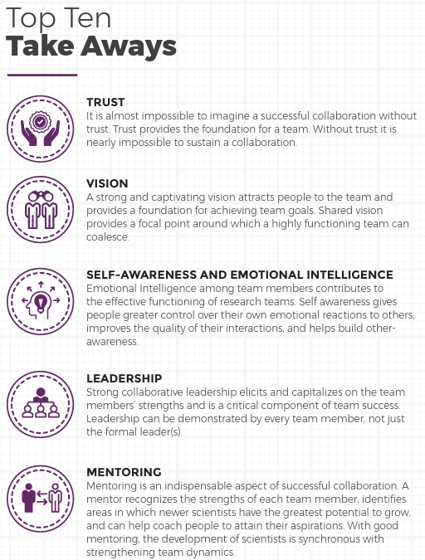

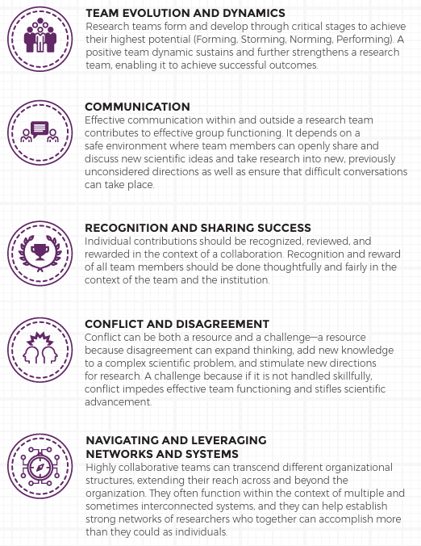

National Institutes of Health. (2010). Collaboration and Team Science: A field guide (L. M. Bennett & H. Gadlin, Eds.). National Cancer Institute. https://www.cancer.gov/about-nci/organization/crs/research-initiatives/team-science-field-guide/collaboration-team-science-guide.pdf [healthipe.utexas.edu]

Psychological Safety in Teams
Practice | Source & Explanation
Invite Input (“Let’s go around…” phrases) | AHRQ emphasizes equitability in participation [ahrq.gov]
Normalize Uncertainty (“It’s okay to make mistakes…” statements) | Encourages openness and growth mindset [ahrq.gov]
Celebrate Learning from Failure | Reframes setbacks as learning opportunities within a team [ahrq.gov], [centreforfacdev.ca]
Leadership Modeling | Leaders ask questions, acknowledge limits, and thank contributors, keys to building safety [psnet.ahrq.gov], [ahrq.gov]
Consistent Structures (CUSP, briefs, huddles, debriefs) | Integrating these improves safety culture and normalizes speaking up [psnet.ahrq.gov], [ahrq.gov]
Addressing Hierarchy | Awareness and mitigation of hierarchical barriers promote inclusion [centreforfacdev.ca]
Supportive Leadership Behaviors | Leaders focusing on psychological needs during one-on-ones can foster safety [cepr.org], [sloanreview.mit.edu]

Safety Responsibilities in Team Communication
All team members are responsible for collaborative communication. When an issue arises, all members are required to 1) speak up, and 2) use active listening to understand what others are saying.

Note: Active listening does not imply agreement or a duty to only select one possible solution. Additional conversation should occur to determine next steps.

Activity #4 Debrief Questions
The group facilitator will select from the below questions.

Synthesis & Key Takeaways
- What is your key takeaway from today? (Everyone responds)

Reflection on Team Functioning
- Did you learn anything from hearing CUS statements from other professions?
- How does CUS support psychological safety? How might it fall short if not used effectively?
- What is your responsibility to speak up when you notice a potential risk or inequity?
- What strategies can you use to ensure everyone feels heard?

Communication & Shared Understanding
- What does clear communication look like to you?
- How did the team reason through the problem today and make decisions? What worked well?

Team Roles, Leadership & Adaptability
- How did professional roles and perceived hierarchies influence who spoke up, how ideas were received, and how decisions were made?
- What strategies helped the team adapt roles and responsibilities during the discussion?
- What steps can you take to ensure effective teamwork in a time-limited, high-pressure setting?

Accountability, Decision Ownership & Outcomes
- How did you ensure accountability for the outcome of your plan?
- How did the team reason through the problem and make decisions?

Patient as Team Member & Shared Decision-Making
- What other techniques could you use to include the patient as a team member in decision-making?
- What does patient-centered care look like?

Systems, Resources & Constraints
- What organizational or resource limitations did you identify, and how did they impact your team’s effectiveness?
- What is the role of research and basic science in healthcare delivery?

All attendees will return to the main room
for final evaluation at the time stated on the agenda.
Facilitators: If staying for afternoon session,
disconnect and start the next zoom session sent by Margaret Robinson

